eInfochips Training & Research Academy
Lab-Level 0
Exercise 1

1. Log on a Linux machine Enter your login (user name) and password at relevant prompts.
->done.
2.Enter these commands at the UNIX prompt, and try to interpret the output. Ask questions and don't be afraid to experiment (as a normal user you cannot do much harm)
1)echo hello world

display a line of text


2}passwd

The passwd command changes passwords for user accounts.

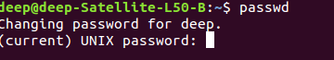

3)Date
Date command is helpful to display date in several formats. It also allows you to set systems date and time.

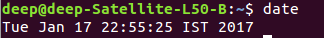

4)hostname
The hostname command shows or sets the system hostname.

5)arch
Display the architecture of the current host.


6)uname
7)dmesg | more
The ‘dmesg‘ command displays the messages from the kernel ring buffer.
The output of this command typically contains the messages produced by the device drivers

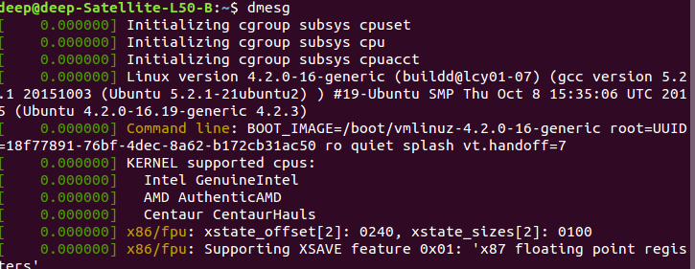

8)uptime
uptime tells you how long the system has been running.

9)who am i
whoami prints the effective user ID.

10)who
Displays who is logged in to the system
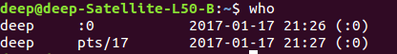
.

11)id
Prints real and effective user and group Ids.
12)last
Show listing of the most recently logged in users.
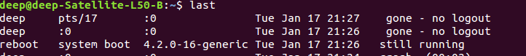
13)finger
Finger may be used to look up users on a remote machine.
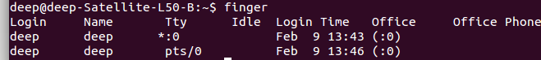
14)w
The w command is a quick way to see who is logged on and what they are doing.
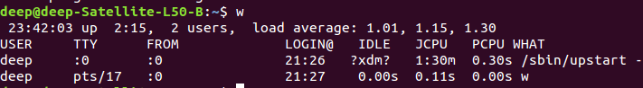
15)top (you may need to press q to quit)
The top program provides a dynamic real-time view of a running system. It can display system summary information, as well as a list of processes or threads currently being managed by the kernel.
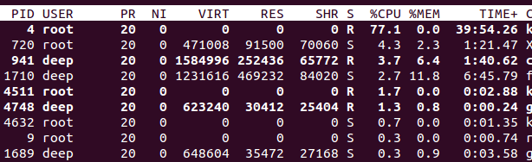
16)echo $SHELL

17)echo {con,pre}{sent,fer}{s,ed}
18)man "automatic door"
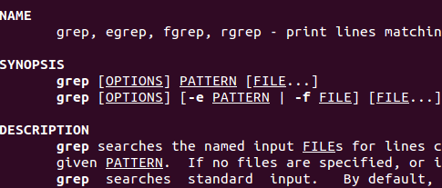

19)man ls
man is used to command info.
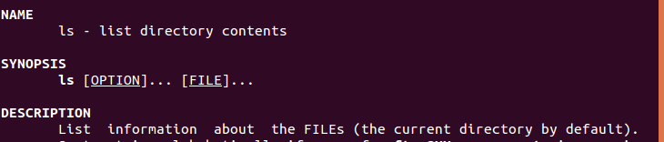
20)man who (you may need to press q to quit)
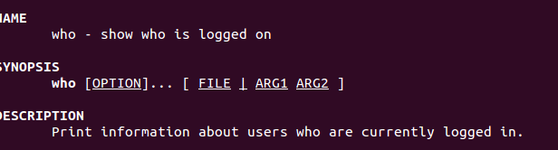
21)lost

22)clear
clear the content of terminal.
23)cal 2000
Display a conveniently-formatted calendar from the command line.
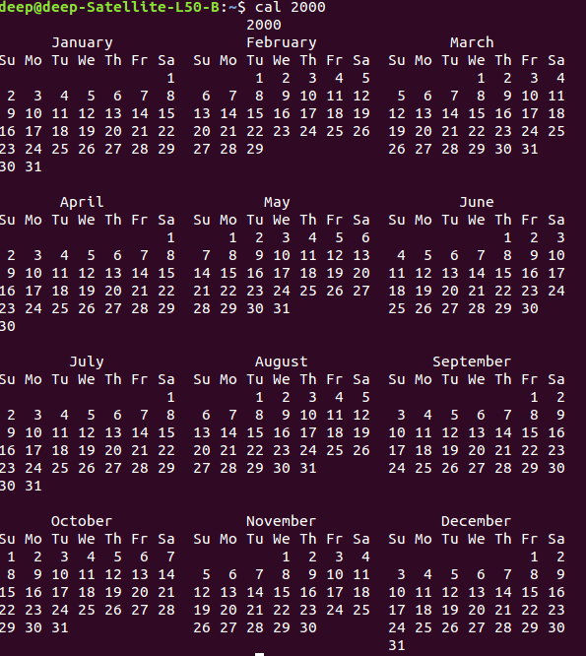

24)cal 9 1752 (do you notice anything unusual?)
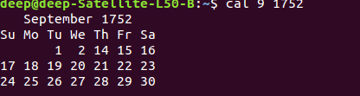

25)bc
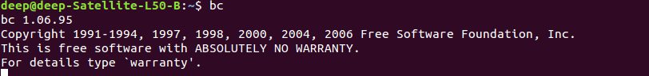
26)echo 5+4 | bc
do aithmetic operation

27)yes please
The yes command is used to output "y", or whatever word you choose, forever.
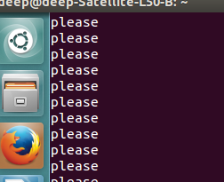

28)time sleep 5
The sleep command is used to delay for a specified amount of time.

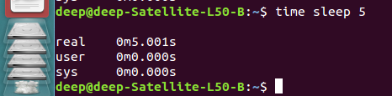

29)history
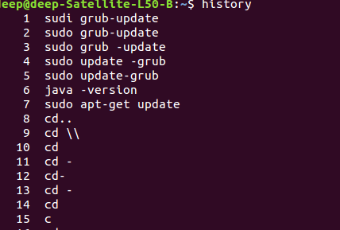

Exercise 2
1 Try the following command sequence:

1.cd
2.pwd
deep@deep-Satellite-L50-B:~$ pwd
/home/deep
3.ls -al
show all file with long list
deep@deep-Satellite-L50-B:~$ ls -al
total 132
drwxr-xr-x 17 deep deep 4096 Jan 18 07:12 .
drwxr-xr-x 5 root root 4096 Jan 17 16:56 ..
-rw------- 1 deep deep 4822 Jan 18 00:29 .bash_history
-rw-r--r-- 1 deep deep 220 Mar 30 2016 .bash_logout
-rw-r--r-- 1 deep deep 3771 Mar 30 2016 .bashrc
drwx------ 22 deep deep 4096 Jan 17 23:27 .cache
drwx------ 22 deep deep 4096 Jan 17 22:43 .config
-rw-rw-rw- 1 deep deep 25 Jan 17 12:56 deep.txt
drwxr-xr-x 2 deep deep 4096 Mar 30 2016 Desktop
-rw-rw-r-- 1 deep deep 25 Jan 17 13:04 dhuv.txt
drwxr-xr-x 2 deep deep 4096 Mar 30 2016 Documents
drwxr-xr-x 2 deep deep 4096 Jan 18 07:13 Downloads
-rw-r--r-- 1 deep deep 8980 Mar 30 2016 examples.desktop
drwx------ 3 deep deep 4096 Jan 18 07:13 .gconf
-rw------- 1 deep deep 4444 Jan 18 07:12 .ICEauthority
drwx------ 3 deep deep 4096 Mar 30 2016 .local
drwxrwxr-x 3 deep deep 4096 Jan 17 17:24 main
drwx------ 4 deep deep 4096 Mar 30 2016 .mozilla
drwxr-xr-x 2 deep deep 4096 Mar 30 2016 Music
drwxr-xr-x 2 deep deep 4096 Jan 18 00:24 Pictures
drwxrwxr-x 2 deep deep 4096 Jan 17 17:15 play
-rw-r--r-- 1 deep deep 675 Mar 30 2016 .profile
drwxr-xr-x 2 deep deep 4096 Mar 30 2016 Public
-rw-r--r-- 1 deep deep 0 Mar 30 2016 .sudo_as_admin_successful
drwxr-xr-x 2 deep deep 4096 Mar 30 2016 Templates
-rw-rw-r-- 1 deep deep 18 Jan 17 13:27 toda.txt
drwxr-xr-x 2 deep deep 4096 Mar 30 2016 Videos
-rw------- 1 deep deep 65 Jan 18 07:12 .Xauthority
-rw------- 1 deep deep 1076 Jan 18 07:13 .xsession-errors
-rw------- 1 deep deep 2518 Jan 18 00:29 .xsession-errors.old
4.cd .
5.pwd (where did that get you?)
deep@deep-Satellite-L50-B:~$ pwd
/home/deep
6.cd ..
deep@deep-Satellite-L50-B:~$ cd ..
deep@deep-Satellite-L50-B:/home$
7.pwd
deep@deep-Satellite-L50-B:/home$ pwd
/home
8.ls -al
deep@deep-Satellite-L50-B:/home$ ls -al
total 20
drwxr-xr-x 5 root root 4096 Jan 17 16:56 .
drwxr-xr-x 23 root root 4096 Mar 30 2016 ..
drwxr-xr-x 17 deep deep 4096 Jan 18 07:12 deep
drwxr-xr-x 2 deep1 deep1 4096 Jan 17 16:56 deep1
drwxr-xr-x 5 hduser hadoop 4096 Apr 4 2016 hduser
9.cd ..
deep@deep-Satellite-L50-B:/home$ cd ..
deep@deep-Satellite-L50-B:/$
10.pwd
deep@deep-Satellite-L50-B:/$ pwd
/
11.ls -al
deep@deep-Satellite-L50-B:/$ ls -al.
total 104
drwxr-xr-x 23 root root 4096 Mar 30 2016 .
drwxr-xr-x 23 root root 4096 Mar 30 2016 ..
drwxr-xr-x 2 root root 4096 Mar 30 2016 bin
drwxr-xr-x 3 root root 4096 Mar 30 2016 boot
drwxr-xr-x 2 root root 4096 Mar 30 2016 cdrom
drwxr-xr-x 19 root root 4580 Jan 18 07:12 dev
drwxr-xr-x 133 root root 12288 Jan 17 16:56 etc
drwxr-xr-x 5 root root 4096 Jan 17 16:56 home
lrwxrwxrwx 1 root root 32 Mar 30 2016 initrd.img -> boot/initrd.img-4.2.0-16-generic
drwxr-xr-x 24 root root 4096 Mar 30 2016 lib
drwxr-xr-x 2 root root 4096 Oct 21 2015 lib64
drwx------ 2 root root 16384 Mar 30 2016 lost+found
drwxr-xr-x 3 root root 4096 Mar 30 2016 media
drwxr-xr-x 2 root root 4096 Oct 19 2015 mnt
drwxr-xr-x 2 root root 4096 Oct 21 2015 opt
dr-xr-xr-x 217 root root 0 Jan 18 07:12 proc
drwx------ 3 root root 4096 Apr 4 2016 root
drwxr-xr-x 27 root root 800 Jan 18 07:13 run
drwxr-xr-x 2 root root 12288 Mar 30 2016 sbin
drwxr-xr-x 2 root root 4096 Oct 21 2015 srv
dr-xr-xr-x 13 root root 0 Jan 18 07:12 sys
drwxrwxrwt 11 root root 4096 Jan 18 07:30 tmp
drwxr-xr-x 11 root root 4096 Oct 21 2015 usr
drwxr-xr-x 13 root root 4096 Oct 21 2015 var
lrwxrwxrwx 1 root root 29 Mar 30 2016 vmlinuz -> boot/vmlinuz-4.2.0-16-generic
12.cd ..
13.pwd (what happens now)
deep@deep-Satellite-L50-B:/$ cd ..
deep@deep-Satellite-L50-B:/$ pwd
/
14.cd /etc
deep@deep-Satellite-L50-B:/$ cd /etc
deep@deep-Satellite-L50-B:/etc
15.ls al |more
deep@deep-Satellite-L50-B:/etc$ ls -al|more
total 1152
drwxr-xr-x 133 root root 12288 Jan 17 16:56 .
drwxr-xr-x 23 root root 4096 Mar 30 2016 ..
drwxr-xr-x 3 root root 4096 Oct 21 2015 acpi
-rw-r--r-- 1 root root 3028 Oct 21 2015 adduser.conf
drwxr-xr-x 2 root root 12288 Apr 4 2016 alternatives
-rw-r--r-- 1 root root 401 Dec 29 2014 anacrontab
-rw-r--r-- 1 root root 112 Jan 10 2014 apg.conf
drwxr-xr-x 6 root root 4096 Oct 21 2015 apm
drwxr-xr-x 3 root root 4096 Oct 21 2015 apparmor
drwxr-xr-x 8 root root 4096 Oct 21 2015 apparmor.d
drwxr-xr-x 5 root root 4096 Oct 21 2015 apport
drwxr-xr-x 6 root root 4096 Mar 30 2016 apt
drwxr-xr-x 3 root root 4096 Oct 21 2015 aptdaemon
drwxr-xr-x 2 root root 4096 Oct 21 2015 at-spi2
drwxr-xr-x 3 root root 4096 Oct 21 2015 avahi
-rw-r--r-- 1 root root 2188 Sep 1 2015 bash.bashrc
-rw-r--r-- 1 root root 45 Aug 13 2015 bash_completion
drwxr-xr-x 2 root root 4096 Mar 30 2016 bash_completion.d
-rw-r--r-- 1 root root 367 May 19 2014 bindresvport.blacklist
drwxr-xr-x 2 root root 4096 Oct 15 2015 binfmt.d
drwxr-xr-x 2 root root 4096 Oct 21 2015 bluetooth
-rw-r--r-- 1 root root 33 Oct 21 2015 brlapi.key
--More--
16.cat passwd
deep@deep-Satellite-L50-B:/etc$ cat passwd
root:x:0:0:root:/root:/bin/bash
daemon:x:1:1:daemon:/usr/sbin:/usr/sbin/nologin
bin:x:2:2:bin:/bin:/usr/sbin/nologin
sys:x:3:3:sys:/dev:/usr/sbin/nologin
sync:x:4:65534:sync:/bin:/bin/sync
games:x:5:60:games:/usr/games:/usr/sbin/nologin
man:x:6:12:man:/var/cache/man:/usr/sbin/nologin
lp:x:7:7:lp:/var/spool/lpd:/usr/sbin/nologin
mail:x:8:8:mail:/var/mail:/usr/sbin/nologin
news:x:9:9:news:/var/spool/news:/usr/sbin/nologin
uucp:x:10:10:uucp:/var/spool/uucp:/usr/sbin/nologin
proxy:x:13:13:proxy:/bin:/usr/sbin/nologin
www-data:x:33:33:www-data:/var/www:/usr/sbin/nologin
backup:x:34:34:backup:/var/backups:/usr/sbin/nologin
list:x:38:38:Mailing List Manager:/var/list:/usr/sbin/nologin
irc:x:39:39:ircd:/var/run/ircd:/usr/sbin/nologin
gnats:x:41:41:Gnats Bug-Reporting System (admin):/var/lib/gnats:/usr/sbin/nologin
nobody:x:65534:65534:nobody:/nonexistent:/usr/sbin/nologin
systemd-timesync:x:100:103:systemd Time Synchronization,,,:/run/systemd:/bin/false
systemd-network:x:101:104:systemd Network Management,,,:/run/systemd/netif:/bin/false
systemd-resolve:x:102:105:systemd Resolver,,,:/run/systemd/resolve:/bin/false
systemd-bus-proxy:x:103:106:systemd Bus Proxy,,,:/run/systemd:/bin/false
syslog:x:104:109::/home/syslog:/bin/false
messagebus:x:105:110::/var/run/dbus:/bin/false
uuidd:x:106:111::/run/uuidd:/bin/false
avahi:x:107:114:Avahi mDNS daemon,,,:/var/run/avahi-daemon:/bin/false
whoopsie:x:108:115::/nonexistent:/bin/false
avahi-autoipd:x:109:118:Avahi autoip daemon,,,:/var/lib/avahi-autoipd:/bin/false
dnsmasq:x:110:65534:dnsmasq,,,:/var/lib/misc:/bin/false
colord:x:111:121:colord colour management daemon,,,:/var/lib/colord:/bin/false
speech-dispatcher:x:112:29:Speech Dispatcher,,,:/var/run/speech-dispatcher:/bin/false
hplip:x:113:7:HPLIP system user,,,:/var/run/hplip:/bin/false
kernoops:x:114:65534:Kernel Oops Tracking Daemon,,,:/:/bin/false
pulse:x:115:122:PulseAudio daemon,,,:/var/run/pulse:/bin/false
rtkit:x:116:124:RealtimeKit,,,:/proc:/bin/false
saned:x:117:125::/var/lib/saned:/bin/false
usbmux:x:118:46:usbmux daemon,,,:/var/lib/usbmux:/bin/false
lightdm:x:119:126:Light Display Manager:/var/lib/lightdm:/bin/false
deep:x:1000:1000:Deep,,,:/home/deep:/bin/bash
hduser:x:1001:1001:deep shah,404,123456,2345,124:/home/hduser:/bin/bash
sshd:x:120:65534::/var/run/sshd:/usr/sbin/nologin
deep1:x:1002:1002:,,,:/home/deep1:/bin/bash
17.cd
18.pwd
deep@deep-Satellite-L50-B:/etc$ cd
deep@deep-Satellite-L50-B:~$ pwd
/home/deep
2 Continue to explore the filesystem tree using cd, ls, pwd and cat. Look in /bin, /usr/bin, /sbin,/tmp and /boot. What do you see?
1.cd /bin
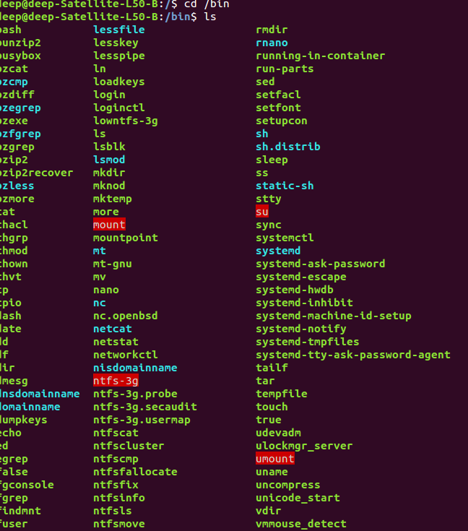
2.cd /usr/bin
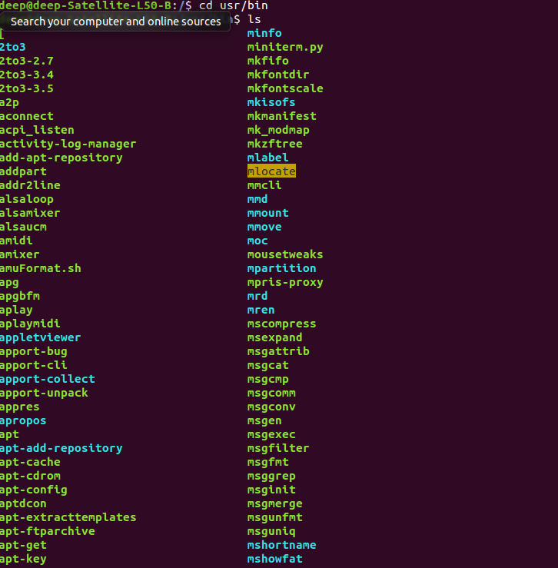
3.cd /sbin
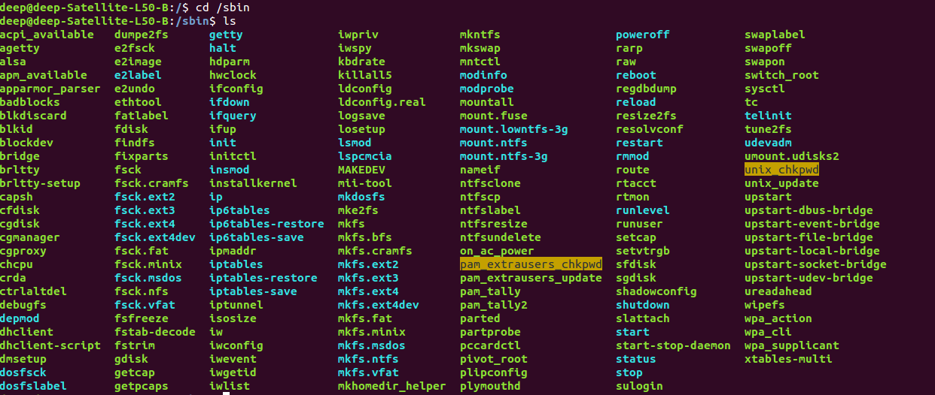
4.cd /tmp
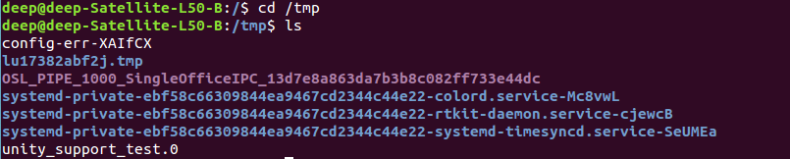
5.cd /boot
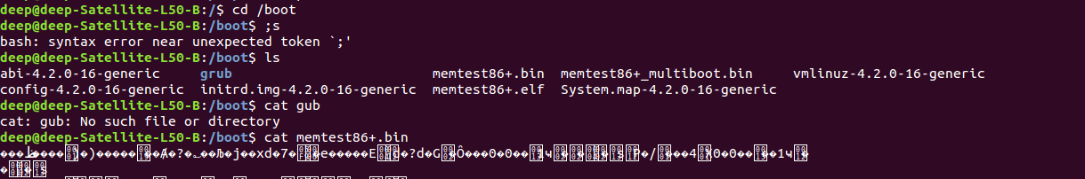
3 Explore /dev. Can you identify what devices are available? Which are character oriented and which are block oriented? Can you identify your tty (terminal)device (typing who am i might help); who is the owner of your tty (use ls l)?
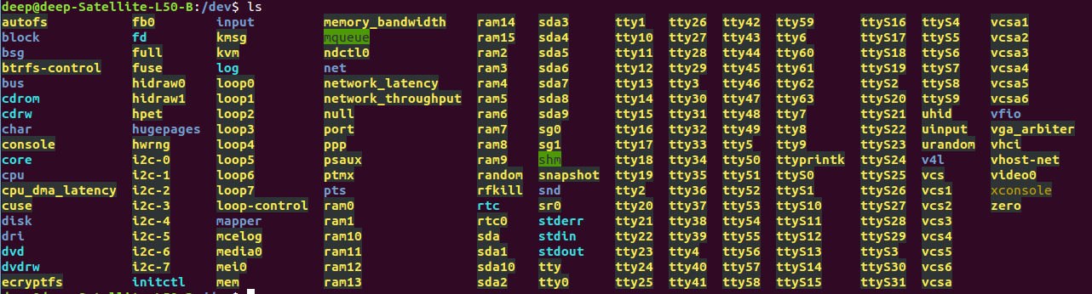
Examples for Character Devices: serial ports, parallel ports, sounds cards. ,Examples for Block Devices: hard disks, USB cameras, Disk-On-Key.
4 Explore /proc. Display the contents of the files interrupts, devices, cpuinfo, meminfo and uptime using cat. Can you see why we say /proc is a pseudo filesystem which allows access to kernel data structures?

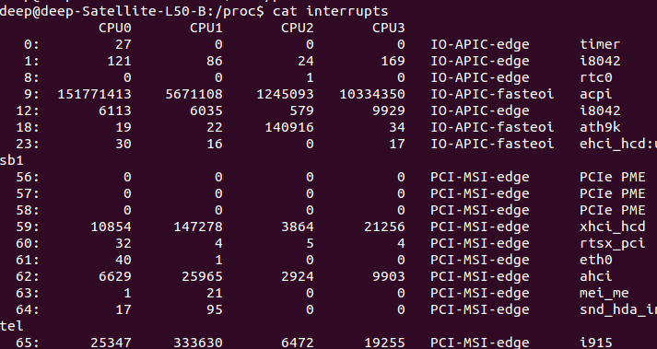
->deep@deep-Satellite-L50-B:/proc$ cat devices
Character devices:
1 mem
4 /dev/vc/0
4 tty
4 ttyS
5 /dev/tty
5 /dev/console
5 /dev/ptmx
5 ttyprintk
6 lp
7 vcs
10 misc
13 input
14 sound
21 sg
29 fb
81 video4linux
99 ppdev
108 ppp
116 alsa
128 ptm
136 pts
180 usb
189 usb_device
216 rfcomm
226 drm
250 media
251 hidraw
252 bsg
253 watchdog
254 rtc

Block devices:
1 ramdisk
259 blkext
7 loop
8 sd
9 md
11 sr
65 sd
66 sd
67 sd
68 sd
69 sd
70 sd
71 sd
128 sd
129 sd
130 sd
131 sd
132 sd
133 sd
134 sd
135 sd
252 device-mapper
253 virtblk
254 mdp

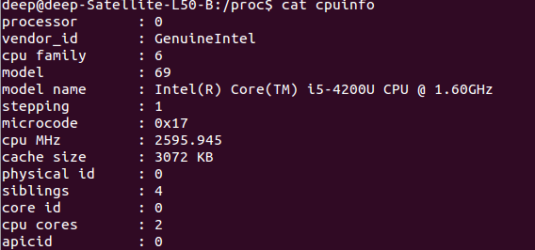
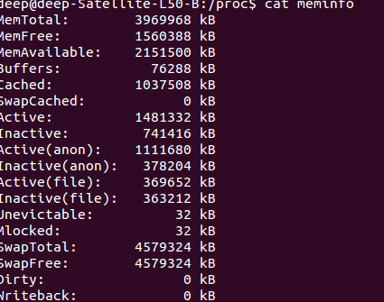

5 Change to the home directory of another user directly, using cd ~username.

6 Change back into your home directory.
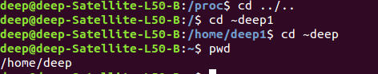

7.Makesubdirectories called work and play.
8 Delete the subdirectory called work.
9 Copy the file /etc/passwd into your home directory.
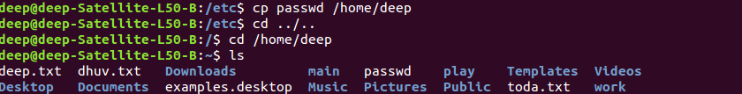
10 Move it into the subdirectory play.
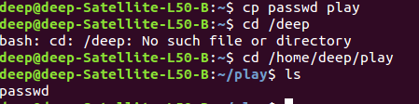

11 Change into subdirectory play and create a symbolic link called terminal that points to your tty device. What happens if you try to make a hard link to the tty device?
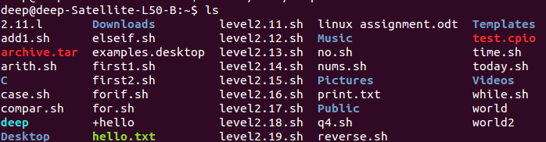

12 What is the difference between listing the contents of directory play with ls l and ls L?
Ls -l =long list ls -L means it display normal list woth symbolic link
13 Create a file called hello.txt that contains the words "hello world". Can you use cp using "terminal" as the source file to achieve the same effect?
Cp hello.txt a.txt
14 Copy hello.txt to terminal. What happens?
->We Get Absolute Path Of Hello.Txt File
15 Imagine you were working on a system and someone accidentally deleted the ls command (/bin/ls). How could you get a list of the files in the current directory?
dir\b
16 How would you create and then delete a file called "$SHELL"? Try it.
17 How would you create and then delete a file that begins with the symbol #? Try it.
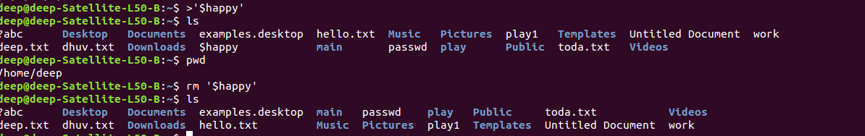

18 How would you create and then delete a file that begins with the symbol ? Try it.
19 What is the output of the command: echo {con,pre}{sent,fer}{s,ed}? Now, from your home directory, copy /etc/passwd and /etc/group into your home directory in one command given that you can only type /etc once.

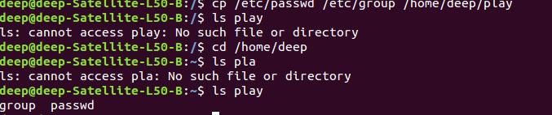
20 Still in your home directory, copy the entire directory play to a directory called work, preserving the symbolic link.
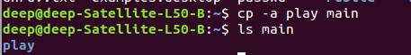

21 Delete the work directory and its contents with one command. Accept no om plaints or queries.

22 Change into a directory that does not belong to you and try to delete all the files (avoid /proc or /dev, just in case!)
/proc$ rm *
rm: cannot remove '1': Is a directory
rm: cannot remove '10': Is a directory
rm: cannot remove '101': Is a directory
rm: cannot remove '102': Is a directory

23 Experiment with the options on the ls command. What do the d, i, R and F options do?
deep@deep-Satellite-L50-B:/dev$ ls -i
475 autofs 131 ram5 70 tty51
230 block 132 ram6 71 tty52
373 bsg 133 ram7 72 tty53
482 btrfs-control 134 ram8 73 tty54
154 bus 135 ram9 74 tty55
494 cdrom 10 random 75 tty56
495 cdrw 4 rfkill 76 tty57
186 char 225 rtc 77 tty58
14 console 169 rtc0 78 tty59
181 core 375 sda 25 tty6
83 cpu 379 sda1 79 tty60

deep@deep-Satellite-L50-B:/dev$ ls -r
zero ttyS24 tty48 tty12 ram14 i2c-6
xconsole ttyS23 tty47 tty11 ram13 i2c-5
video0 ttyS22 tty46 tty10 ram12 i2c-4
vhost-net ttyS21 tty45 tty1 ram11 i2c-3
vhci ttyS20 tty44 tty0 ram10 i2c-2
vga_arbiter ttyS2 tty43 tty ram1 i2c-1
vfio ttyS19 tty42 stdout ram0 i2c-0
vcsa6 ttyS18 tty41 stdin pts hwrng
vcsa5 ttyS17 tty40 stderr ptmx
deep@deep-Satellite-L50-B:/dev$ ls -f

. sda9 rtc0 ttyS27 tty58 tty19
.. sda8 uinput ttyS26 tty57 tty18
hidraw1 sda7 psaux ttyS25 tty56 tty17
hidraw0 sda6 input ttyS24 tty55 tty16
v4l sda5 bus ttyS23 tty54 tty15
video0 sda4 ppp ttyS22 tty53 tty14
media0 sda3 net ttyS21 tty52 tty13
kvm sda2 loop7 ttyS20 tty51 tty12
vcsa6 sda1 loop6 ttyS19 tty50 tty11
vcs6 sg1 loop5 ttyS18 tty49 tty10
vcsa5 sr0 loop4 ttyS17 tty48 tty9
vcs5 sda loop3 ttyS16 tty47 tty8
vcsa4 bsg loop2 ttyS15 tty46 tty7
vcs4 sg0 loop1 ttyS14 tty45 tty6
vcsa3 fb0 loop0 ttyS13 tty44 tty5
vcs3 i2c-7 loop-control ttyS12 tty43 tty4
vcsa2 i2c-6 ram15 ttyS11 tty42 tty3
vcs2 i2c-5 ram14 ttyS10 tty41 tty2
dvdrw i2c-4 ram13 ttyS9 tty40 tty1
dvd i2c-3 ram12 ttyS8 tty39 vcsa1
cdrw i2c-2 ram11 ttyS7 tty38 vcs1
cdrom i2c-1 ram10 ttyS6 tty37 vcsa
mei0 block ram9 ttyS5 tty36 vcs
xconsole i2c-0 ram8 ttyS4 tty35 tty0
snd dri ram7 ttyS3 tty34 console
vhost-net rtc ram6 ttyS2 tty33 tty
uhid char ram5 ttyS1 tty32 kmsg
vhci stderr ram4 ttyS0 tty31 urandom
vfio stdout ram3 ptmx tty30 random
btrfs-control stdin ram2

Exercise 3
___________________________________________
1 Describe three different ways of setting the permissions on a file or directory to rrr. Create a file and see if this works.
1) chmod
2)umask
3) graphicaly (properties->permission)
2 Type umask 000 and then create a file called world.txt containing the words hello world. Look at the permissions on the file. What's happened? Now type umask 022 and create a file called world2.txt. When might this feature be useful?
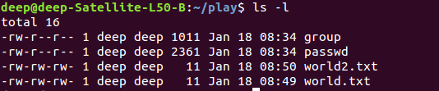
3 Use find to display the names of all files in the /home subdirectory tree. Can you do this without displaying errors for files you can't read.
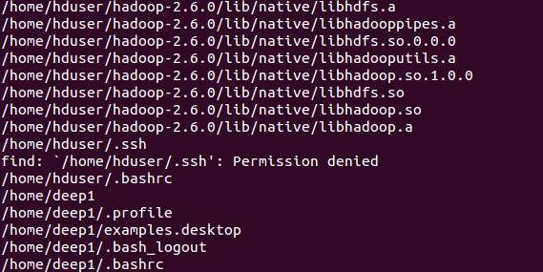

4 Use find to display the names of all files in the system that are bigger than 1MB.
find *.* /home -size +1M
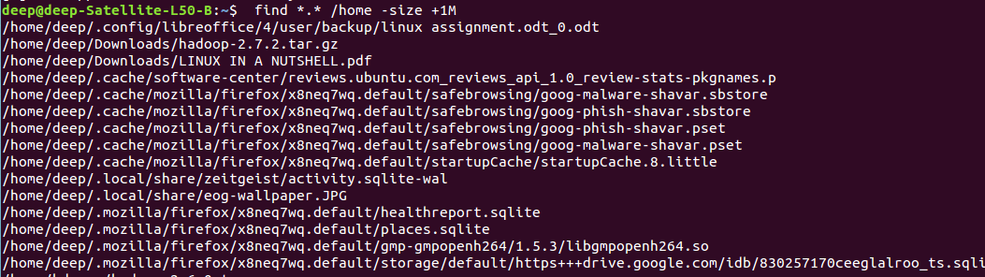

+
5 Use find and file to display all files in the /home subdirectory tree, as well as a guess at what sort of a file they are. Do this in two different ways.

6 Use grep to isolate the line in /etc/passwd that contains your login details.
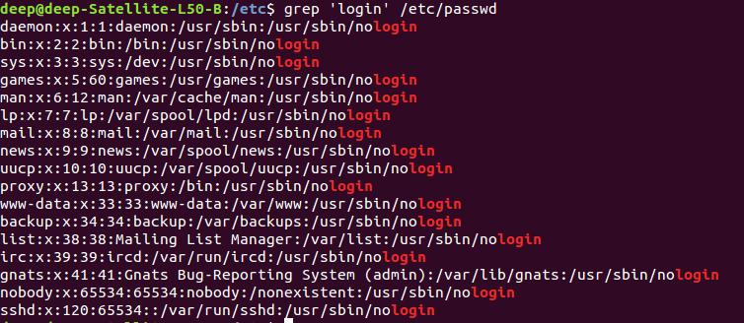
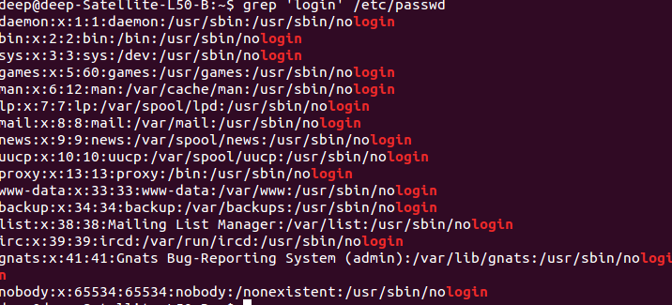

7 Use find and grep and sort to display a sorted list of all files in the /home subdirectory tree that contain the word hello somewhere inside them.

8 Use locate to find all filenames that contain the word emacs. Can you combine his with grep to avoid displaying all filenames containing the word lib?
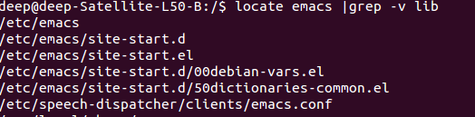
9 Archive the contents of your home directory (including any subdirectories) using tar and cpio.Compress the tar archive with compress, and the cpio archive with gzip. Now extract theircontents.
tar -czf archive.tar.gz home/ for compress
tar -xvf archive.tar.gz home/ for decompress
10 On Linux systems, the file /dev/urandom is a constantly generated random stream of characters. Can you use this file with od to printout a random decimal number?
deep@deep-Satellite-L50-B:/$ od -An -N8 -i/dev/random

11 Type mount (with no parameters) and try to interpret the output.
sysfs on /sys type sysfs (rw,nosuid,nodev,noexec,relatime)
proc on /proc type proc (rw,nosuid,nodev,noexec,relatime)
udev on /dev type devtmpfs (rw,nosuid,relatime,size=1969348k,nr_inodes=492337,mode=755)
devpts on /dev/pts type devpts (rw,nosuid,noexec,relatime,gid=5,mode=620,ptmxmode=000)
tmpfs on /run type tmpfs (rw,nosuid,noexec,relatime,size=397344k,mode=755)
/dev/sda8 on / type ext4 (rw,relatime,errors=remount-ro,data=ordered)
securityfs on /sys/kernel/security type securityfs (rw,nosuid,nodev,noexec,relatime)
tmpfs on /dev/shm type tmpfs (rw,nosuid,nodev)
tmpfs on /run/lock type tmpfs (rw,nosuid,nodev,noexec,relatime,size=5120k)
tmpfs on /sys/fs/cgroup type tmpfs (rw,mode=755)
cgroup on /sys/fs/cgroup/systemd type cgroup (rw,nosuid,nodev,noexec,relatime,xattr,release_agent=/lib/systemd/systemd-cgroups-agent,name=systemd)
pstore on /sys/fs/pstore type pstore (rw,nosuid,nodev,noexec,relatime)
cgroup on /sys/fs/cgroup/cpuset type cgroup (rw,nosuid,nodev,noexec,relatime,cpuset,clone_children)
cgroup on /sys/fs/cgroup/blkio type cgroup (rw,nosuid,nodev,noexec,relatime,blkio)
cgroup on /sys/fs/cgroup/memory type cgroup (rw,nosuid,nodev,noexec,relatime,memory)
cgroup on /sys/fs/cgroup/devices type cgroup (rw,nosuid,nodev,noexec,relatime,devices)
cgroup on /sys/fs/cgroup/cpu,cpuacct type cgroup (rw,nosuid,nodev,noexec,relatime,cpu,cpuacct)
cgroup on /sys/fs/cgroup/perf_event type cgroup (rw,nosuid,nodev,noexec,relatime,perf_event,release_agent=/run/cgmanager/agents/cgm-release-agent.perf_event)
cgroup on /sys/fs/cgroup/net_cls,net_prio type cgroup (rw,nosuid,nodev,noexec,relatime,net_cls,net_prio)
cgroup on /sys/fs/cgroup/freezer type cgroup (rw,nosuid,nodev,noexec,relatime,freezer)
cgroup on /sys/fs/cgroup/hugetlb type cgroup (rw,nosuid,nodev,noexec,relatime,hugetlb,release_agent=/run/cgmanager/agents/cgm-release-agent.hugetlb)
systemd-1 on /proc/sys/fs/binfmt_misc type autofs (rw,relatime,fd=29,pgrp=1,timeout=0,minproto=5,maxproto=5,direct)
mqueue on /dev/mqueue type mqueue (rw,relatime)
debugfs on /sys/kernel/debug type debugfs (rw,relatime)
hugetlbfs on /dev/hugepages type hugetlbfs (rw,relatime)
fusectl on /sys/fs/fuse/connections type fusectl (rw,relatime)
cgmfs on /run/cgmanager/fs type tmpfs (rw,relatime,size=100k,mode=755)
tmpfs on /run/user/1000 type tmpfs (rw,nosuid,nodev,relatime,size=397344k,mode=700,uid=1000,gid=1000)
gvfsd-fuse on /run/user/1000/gvfs type fuse.gvfsd-fuse (rw,nosuid,nodev,relatime,user_id=1000,group_id=1000)
/dev/sda7 on /media/deep/New Volume type fuseblk (rw,nosuid,nodev,relatime,user_id=0,group_id=0,default_permissions,allow_other,blksize=4096,uhelper=udisks2)

